The Character being played is now the shadow which is in the character folder of NPCs and labeled shadow.png.



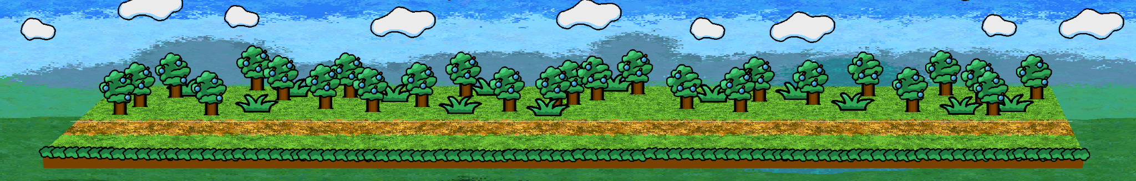

Starting on the far left on the daylevel.png you can only go right until you reach the portal



It is labeled as Portal.png

The player does not need to interact with the portal as it automatically stops them. Once stopped the screen cuts to black and the player is at the start of the level again on the left left except this time they are playing at the butterflylabeled as butterfly.png for the rest of the game.

In the day level where the portal once was is a tree which will automatically stop them like the (noAppleTree.png) portal and display this dialogue

“All the trees look so lovely, I wish I had apples so I could look like them.”

“Hello little butterfly, you wish to know where E@&A&@ went?”

“Sorry but I don’t know but maybe you could get me some apples?”

“Thank you! Please come back here when you are done.”

“Talk to the other residents of the forest maybe they have some apples”

“Maybe get me 3 apples.”

The player's current object is to gain 3 apples by talking to NPCs and trading items. They want to walk left and right and interact with doors to go to different areas.

Everytime the player uses the   
Interact button aka (talking to npcs, using doors) the ActionDone.wav file will play. When the butterfly is walking instead of using the WalkingBetter.wav(in previous folder) just use the butterflyWalk.wav file on loop when moving. Whenever the player receives an item please the PickupSound.wav sound effect.

Once the player has talked to the tree the levels music will start (ForestTheme.wav)

Besides the placement of the portal/tree near the far left the other NPCs/doors can be placed semi randomly in their own respective areas as long as they are “spread out”

In the day level(daylevel.png) besides the tree the 3 npcs to appear with be the snail,raven and tv each named(snail.png, tv.png and raven.png)

The day level will also include a nightDoor.png and a AfterNoonDoor.png which when interacted with will take them to the nightLevel.png or afternoonlevel.png respectively.

In each level they will have doors corresponding to the other levels such as the night level having the dayDoor and AfterNoonDoor and the afternoon level having the dayDoor and AfterNoonDoor respectively.

Whenever you talk to an NPC there will be a check to see if you have the correct item for them or not. If it is your first time talking to the NPC they will display dialogue as if you do not have the item even if you do have it. However after that if you do have the item their dialogue will change.

Whenever you have an item it will be displayed on the top left corner of the screen and since the player can only have about 4 items at a time, 3 apples and key item. There will be no need for a complex counter system. The apples will always be on the left and the key item will be on the right. If the player only has 1 or 2 apples then there will just be space in between the key items and apples as if there is an item there

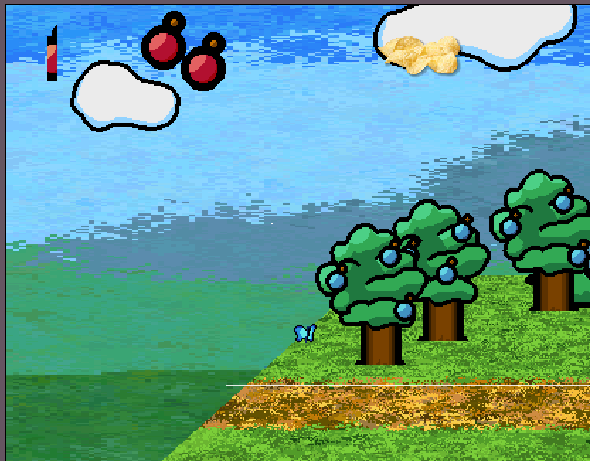

Example Image

I will go by each area in order with the specific NPC dialogue and item needs.

**DAY NPCS-**

****(snail.png)

Dialogue:

“Hello I am Toro the slug.”

“My Fiance is a snail so I wear this shell and pretend to be a snail.”

“Why did I tell you?”

“You seem kind of trustworthy.”

“You are looking for apples?”

“You can have mine.”

“You got ⅓ apple.”

“Maybe you can get more from the other residents but they won’t be as generous as me.”

After talking to him the player will receive the (OneThirdApple.png) and it will appear on the top left of the screen

—---------------------------------------------------------------------------

(raven.png)

Dialogue:

“Caw Caw Caw(Hungry).”

“Caw Caw Caw Caw(Me Kyu-chan will trade cool feather yummy fast food).”

If the player has the (Chips.png) item then the raven will say this next.

“(YOU GAVE CHIPS)”

“CAW CAW CAW(Here is a cool feather)”

And the player will receive the (Feather.png) item

—---------------------------------------------------------------------------

(tv.png)

Dialogue:

“I don't understand humans.”

“Mine watches me everyday and never leaves his apartment.”

“He has never told me his name but every time his mother calls she calls him hikikomori”

“Hikkiomori never brings over any friends.”

“He thinks the people on TV are his friends.”

“If only there was some way to get him to stop watching TV and get him outside.”

“My throat is kinda parched right now, would you mind getting me a drink?”

If the player has the (Tears.png) item then the TV will say

“(YOU GAVE TEARS)”

The screen will cut to black and the glitch.wav sound effect will play.

When the screen is not black anymore the (tv.png) will be replaced with (tvOFF.png)



The dialogue continues with:

“You go to the back to turn on the power switch.”

“It doesn’t work but you find an old bag of chips.”

“(YOU GOT CHIPS)”

The player will receive the (Chips.png) item.

—---------------------------------------------------------------------------

**AFTERNOON NPCS:**

**(**flour.png)

“My name is Flower but I am a Flour . I am dour that I am not a true Flower. Could you help me be empowered and become a true Flower?”

If the player has given the (Gem.png)to (red.png)

Then (flour.png)**** will be changed to (seed.png)and when the player interact with it this dialogue will display:

“Flour has been turned into compost for a flower seed”

“You find 2.541 of an apple.”

The player will then recieve a (twoApple.png)

—---------------------------------------------------------------------------

****(flower.png)

Dialogue:

“My name is Flour but I am a Flower. I am dour that I am not a true flour. Could you help me be empowered and become a true Flour?”

If the player has given the (Gem.png)to (red.png)

Then (flower.png)**** will be changed to (grounded.png)and when the player interact with it this dialogue will display:

“The flower has been ground up and turned into a flour”

“You find ⅛ an apple”

The player will then receive a (OneEightApple.png)

—---------------------------------------------------------------------------

**(**pot.png)

Dialogue:

“I love to sleep because then I don’t have to think about my problems.”

“No thoughts are better than sad ones.”

If the player has the (SadStory.png) then this dialogue will display:

“(You tell a sad story)”

“Why would you tell me this?”

“YOU GET: TEARS”

The player will receive the ”Tears item”

—---------------------------------------------------------------------------

**NIGHT TIME NPCS:**

**(**ghost**.**png**)**

Dialogue:

“Do you want to hear a sad story?”

“When I was alive I was bullied a lot in school.”

“The teachers never helped me and my parents were too busy.”

“One day a shooting star flew brilliantly over the night sky and I made a wish.”

“That all my problems would go away.”

“The next day my school blew up from a ruptured gas pipe and my parents both had simultaneous heart attacks.”

“There are two different types of loneliness.”

“Being alone in a sea of people”

“And being truly alone.”

“This type of loneliness didn't hurt as bad as before.”

“Nobody could torment me for crying.”

“Nobody could chastise me for simply trying.”

“But I soon realized that…”

“I had died in that explosion and my classmates would now bully me forever and ever in the afterlife.”

“Thank you for listening.”

“YOU GOT: SAD STORY”

The player will receive the (SadStory.png) after talking to (ghost.png)****

**—--------------------------------------------------------------------**

****(red.png)

Dialogue:

“Hello my name is Mr.K”

“I have magic powers, I can swap anybody’s bodies”

“I mostly have to use this for Bias tests in certain pig stations.”

“Do you want to see it?”

“Just tell me two people to swap and give me something like a gem and you will be amazed.”

If the player has talked to (flour.png) and (flower.png) and has the (Gem.png) item.

“(YOU GIVE GEM AND TELL HIM ABOUT FLOUR AND FLOWER)”

“Ok time for presto chango”

“There go check it out”

****(doll.png)

Dialogue:

“I am beautiful”

“I am perfect just the way I am”

“I am beautiful”

“I am perfect just the way I am”

“I am…..”

“Disgusting.”

“Maybe if I had a beautiful feather for a hat then my mother would love me.”

If the player has the (Feather.png) then the following dialogue will display

(YOU GAVE FEATHER)

“Here you can gave this beautiful gem.”

(YOU GOT GEM)

The player will then receive the (Gem.png) item.

—---------------------------------------------------------------------------

**AFTER ALL 3 APPLES HAVE BEEN RECEIVED:**

One the player has receive all three apple items they will disappear and they will get the (fullapple.png)

The player must return to the tree to progress

Once the player talks to (noAppleTree.png)the (fullapple.png)

Will removed from their inventory and (noAppleTree.png)will be replaced by

(AppleTree.png) and the following dialogue will take place

“Oh thank you, thank you” “

Now I can be just like everyone else.”

“Oh wait no no no.”

“My apples are red, not blue.”

“Now I stand out even more.”

Before the next dialogue displays the music will stop and (badTree.png) will replace (AppleTree.png)

the following dialogue continues with:

“Why did you do this to me?”

“I just wanted to fit in.”

“Do you hate me?”

“I…”

“I wanna go home.”

The Screen will cut to black and (badTree.png) will be replaced with the original (Portal.png) where the player will interact with to get to the final part of the game.